**DAILY ONLINE ACTIVITIES SUMMARY**

|  |  |  |  |  |  |  |  |  |
| --- | --- | --- | --- | --- | --- | --- | --- | --- |
| **Date:** | **04/06/2020** | | | | | **Name:** | **Manish B Shriyan** | |
| **Sem & Sec** | **8th sem B sec** | | | | | **USN:** | **4AL16CS131** | |
| **Online Test Summary** | | | | | | | | |
| **Subject** | | **SMS** | | | | | | |
| **Max. Marks** | | **60** | | **Score** | | | **60** | |
| **Certification Course Summary** | | | | | | | | |
| **Course** | **IoT Edge Computing: Amazon FreeRTOS Primer** | | | | | | | |
| **Certificate Provider** | | | **AWS** | | **Duration** | | | **3 Hours** |
| **Coding Challenges** | | | | | | | | |
| **Problem Statement:**  **C program for balanced parenthesis** | | | | | | | | |
| **Status: Solved** | | | | | | | | |
| **Uploaded the report in Github** | | | | | **Uploaded** | | | |
| **If yes Repository name** | | | | | **ManishShriyan** | | | |
| **Uploaded the report in slack** | | | | | **Yes** | | | |

Online Test Details:

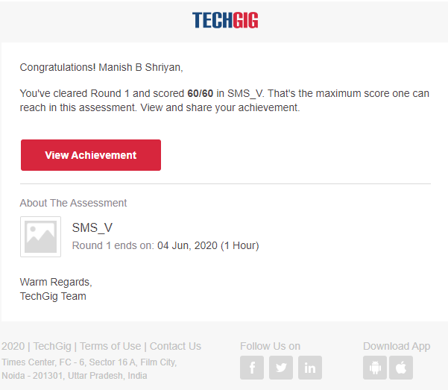

Certification Course Details:

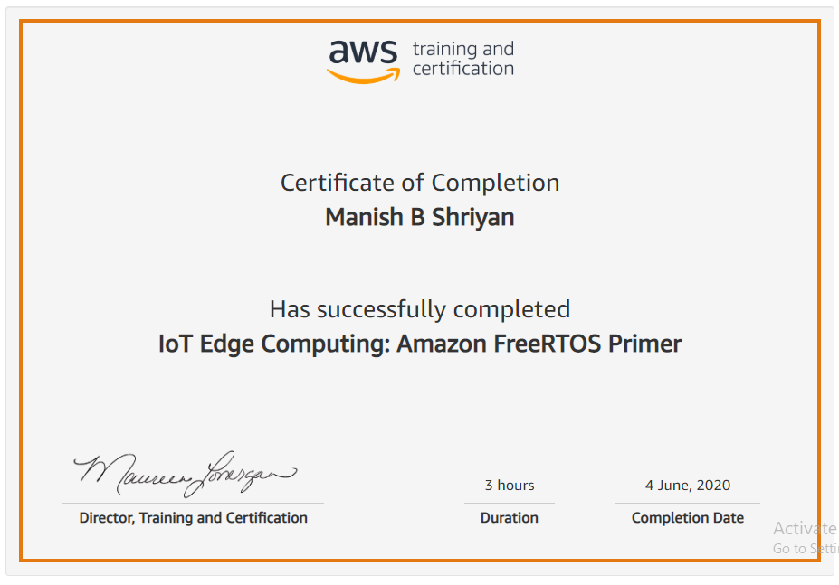

Coding Challenges Details:

|  |
| --- |
|  |
|  |  |
|  |  |
|  |  |
|  |  |
|  |  |
|  |  |
|  |  |
|  |  |
|  |  |
|  |  |

#include <stdio.h>

#include <stdlib.h>

#include <string.h>

int top = -1;

char stack[100];

void push(char);

void pop();

void find_top();

void main()

{

int i;

char a[100];

printf("enter expression\n");

scanf("%s", &a);

for (i = 0; a[i] != '\0';i++)

{

if (a[i] == '(')

{

push(a[i]);

}

else if (a[i] == ')')

{

pop();

}

}

find_top();

}

void push(char a)

{

stack[top] = a;

top++;

}

void pop()

{

if (top == -1)

{

printf("expression is invalid\n");

exit(0);

}

else

{

top--;

}

}

void find_top()

{

if (top == -1)

printf("\nexpression is valid\n");

else

printf("\nexpression is invalid\n");

}